BVN SS1 LẬP TRÌNH C

Bài 1

Bài 2

Bài 3

Bài 4

Bài 5

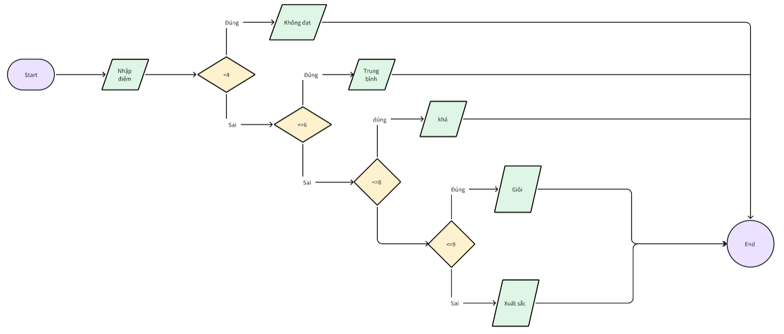

Bài 6

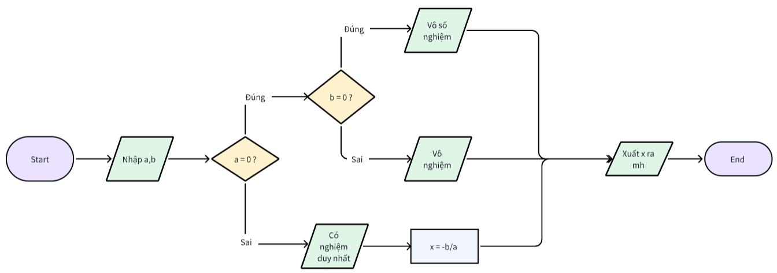

Bài 7

Bài 8

Bài 9 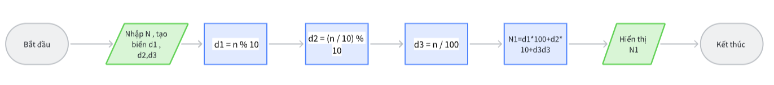

Bài 10

